During this time, we want to ensure that our children remain engaged, challenged, and active.
As we take this time to isolate and shelter ourselves, the hustle and bustle of life has slowed down. The Earth is healing, and certain species of wildlife are coming out more. We should appreciate life and nature, learning the benefit of them.
Nature is defined as the physical world and living things in their natural state; all things that are not made by people.
This includes; Trees, birds, squirrels, flowers, bees and more.
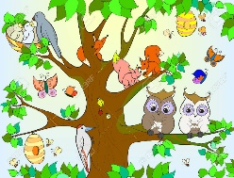
Being outside in nature also benefits us a Human-Beings.
Some benefits are; Memory Improvement, better mood, and ability to focus.
Parts of nature help fuel us, like the Sun.
Do you ever feel slow and droopy when it is raining, or the clouds are covering the sky? But if/when the Sun comes out you become happier or in a better mood?
The Sun gives us a boost in energy, improves our sleep, relieves stress, and provides us with a much-needed vitamin. Vitamin D is a nutrient that our body makes when the Sun hits our skin. Vitamin D builds strong bones, and helps our bones and skin heal.
But before you go lay out in yard to sunbathe always remember to wear skin protection because to much Sun can damage unprotected skin.

This week’s assignment is the Wonderful Walking Trail, which can be done outside (highly recommend) or inside.

Directions BELOW
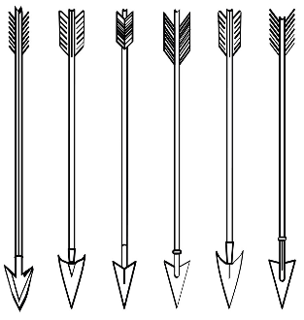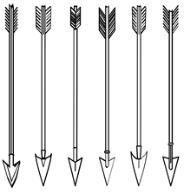

RULES for Outside Play:
With a PARENT/GUARDIAN take a stroll in the neighborhood.
Every time you see a TREE or a BAND OF TREES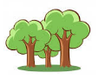, stand in TREE POSE for 20 seconds
If you see a NEST, you REST. SIT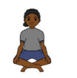 or STAND while you inhale slowly and count to 7, then exhale slowly and count to 11. Repeat 3 times to symbolize to animals being able to rest.
If you see a HILL/MOUNTAIN , stand in MOUNTAIN POSE for 20 seconds
If you see a BRIDGE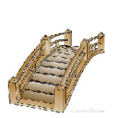, hold a BRIDGE POSE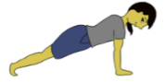 for 20 seconds
End your Wonderful Walking Trail by washing your hands for ATLEAST 20 seconds

RULES for Indoor Play:
With a PARENT/GUARDIAN post signs around the house of the following and follow the directions. You can use the pictures provided or draw your own.

Every time you see a TREE or a BAND OF TREES, stand in TREE POSE for 20 seconds
If you see a NEST, you REST. SIT or STAND while you inhale slowly and count to 7, then exhale slowly and count to 11. Repeat 3 times to symbolize to animals being able to rest.
If you see a HILL/MOUNTAIN , stand in MOUNTAIN POSE for 20 seconds
If you see a BRIDGE, hold a BRIDGE POSE for 20 seconds
End your Wonderful Walking Trail by washing your hands for ATLEAST 20 seconds

