I hope each student enjoyed their time off!
As our first activity back from Spring Break, students will revisit our exercises. Also we will touch on the benefits of fitness.
Exercise improves circulation, giving children a much-needed boost of energy, concentration, and focus. It also helps them balance their energy so that they do not become as tired throughout the day.
Here are a few more ways Physical Fitness helps us:
- It STRENGTHENS our BODIES.
  - Being fit and exercising; it makes our bones stronger, our muscles stronger (especially our lungs AND OUR HEART)

- It REDUCES health risk.
  - Being fit and exercising; keeps you from being overweight, it reduces to risk of developing diseases such as Diabetes, High Blood Pressure, and Cancers
- It makes you feel better.
  - Being fit and exercising; gives you more energy, allows you to relieve stress, and makes you happier

Activity: Dice ‘em Up
- Standards (K-2)
  - PEK.3 PE1.3 PE2.3 - The physically educated student demonstrates knowledge and skills to help achieve and maintain a health-enhancing level of physical activity and fitness.

- Rules:
  - Students will either roll two 6-sided di at home or use an online dice website such as https://www.calculator.net/dice-roller.html to roll two 6-sided di.
  - After adding the two di, the student will complete exercises that same number of times.
    - Ex. 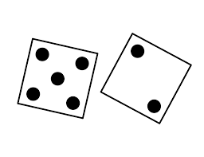 5+2=7. The student will do each exercise a total of 7 times.
- Exercises:
  - Jumping Jacks 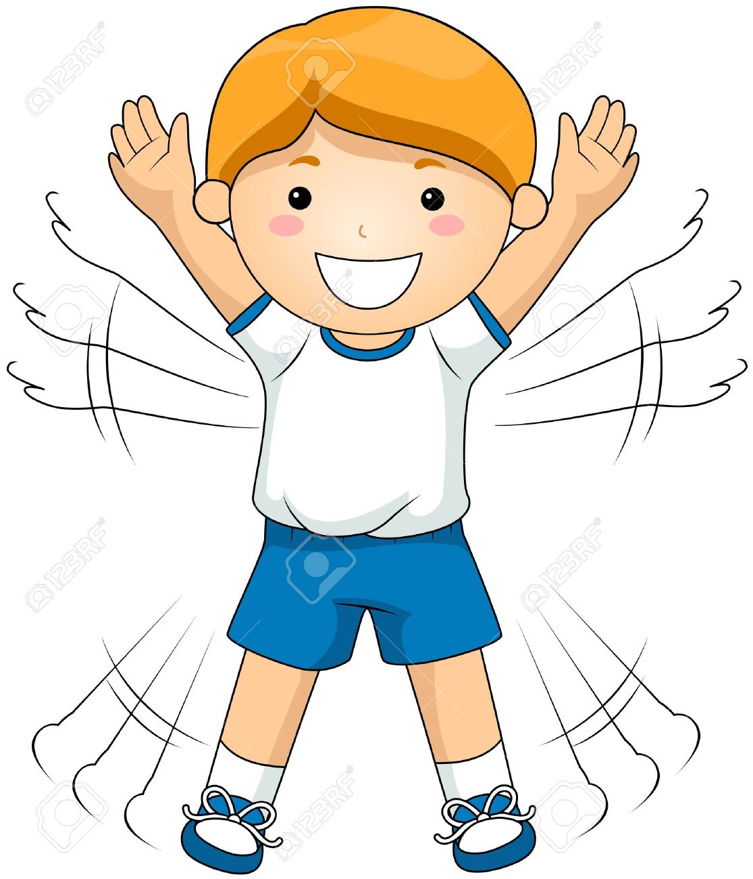
  - Push Ups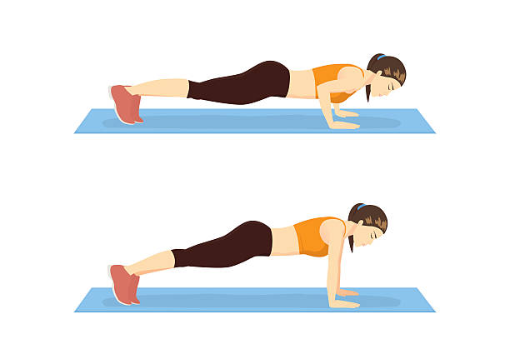

Dice ‘em Up (cont’d)
  - Sit Ups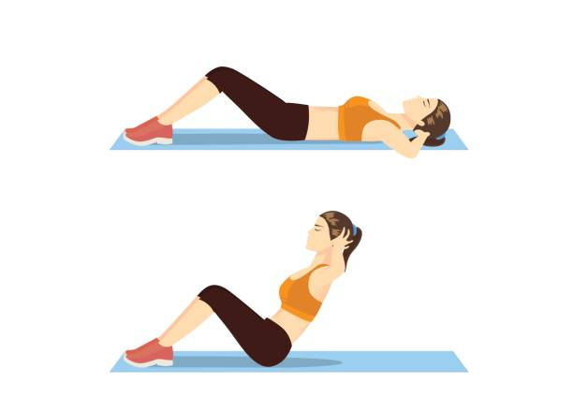
  - Toe Touches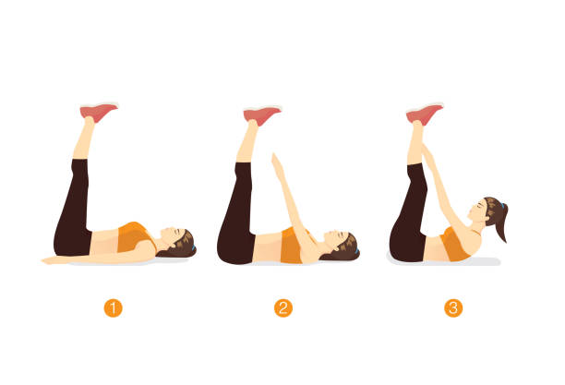
  - Arm Circles (Forward)
  - Arm Circles (Backward) 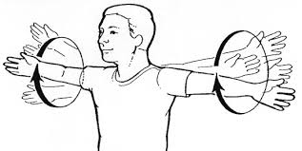
  - Squats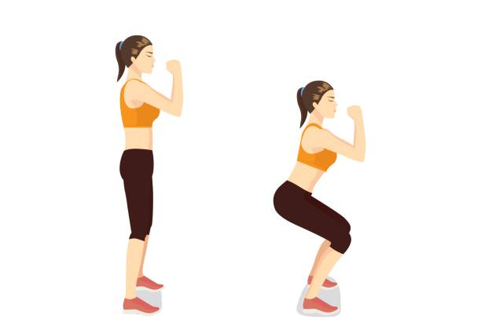
  - Legs Raises (Each Leg) 