3/23/2020-3/27/2020
Today we will start by doing the “Dice ‘em Up” game from yesterday. This game will serve as the warm-up to get us up and moving.
I would like each student to practice juggling this week (at least 30minutes a day) so let’s get familiar with Juggling.
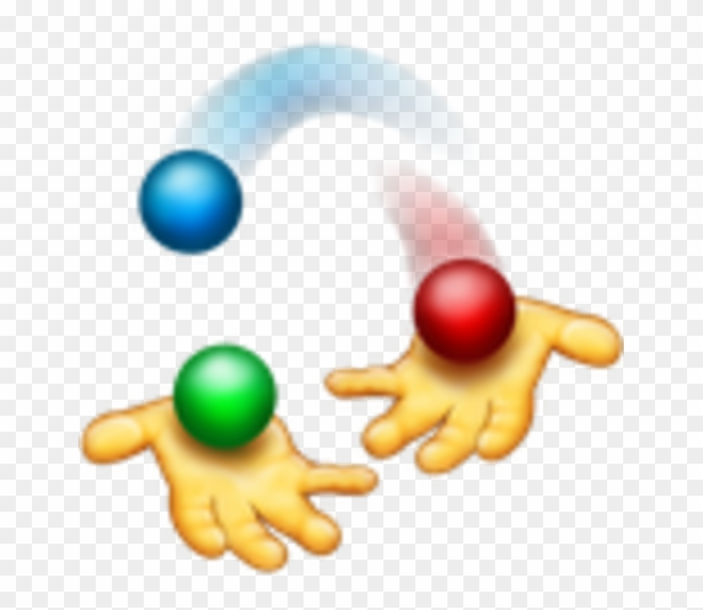
Juggling is a physical skill involving the manipulation of objects. The practice of juggling has been traced back as far as 1781 B.C.E. (3,801 years ago) The oldest record of juggling is from the country of Egypt. When most people think of juggling, they picture a clown.
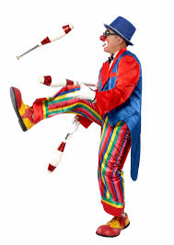
For today’s practice you will need 1-3 wash cloths or dish rags.
Below the printed text is a video link for basic scarf (rag) juggling, follow the video and pause and restart the video for as much practice as needed.
Body Position:
Stand in a relaxed position. Feet parallel about a foot apart, and a slight knee bend. Your hands should be palms up, out in front of you with your elbows bent 90 degrees. RELAX!!!
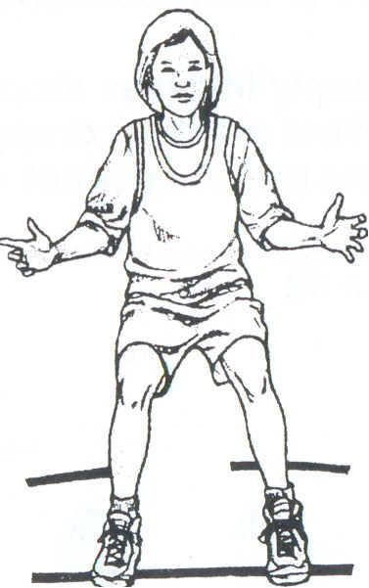
One rag:
Take a single rag and toss it in the air between your hands. The rag should reach up to your nose in between each toss and back to the opposite hand. When the rag travels same path each throw it is called a “shower” juggle. First starting from one hand then the other. Always passing by the same point in front of your nose. Practice this until it feels natural.
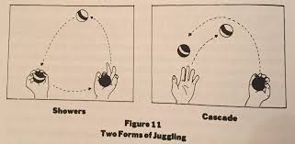
When you toss the ball into the air between each pass it is called a “cascade” juggle. Also practice this until it feels natural. We will now move on to two rags.

Two rags:
Take two tags. Place one in each hand. Begin as you did with one ball, throwing it from one hand past the point in front of your nose. When it has come back down halfway, throw the second ball under it and up to the same point in front of your nose. Pause; then repeat this but this time starting with the opposite hand. Make sure all the throws are the same height and pass the under the incoming rag. Repeat this until it feels natural and is consistent.

Three rags:
Before we begin three balls remember the most important thing in juggling; you already know, the one rag throw learned in the first lesson. This is the only throw you will make when juggling three.
Take three rags. Place two in one hand and one in the other. It doesn't matter which hand has two in it. Whichever feels more comfortable.
Always start with the hand that has two rags on it. Throw the first rag from the hand that has two rags in it. Throw it in the same arch you have practiced. As it falls from throw the single ball in the other hand under it and to the same, point in front nose. As this second rag falls throw the third rag from the start hand, under it and to the same point in front of your nose. Continue the basic pattern.

https://www.youtube.com/watch?v=4aHcmUAWo7I Scarf Juggling Progression Video
https://www.youtube.com/watch?v=ve2FKNctOBg Juggling Two Scarves (Beginner)
https://www.youtube.com/watch?v=uWiZ4fNqu5c Juggling Three Scarves (Beginner)

