During this time, we want to ensure that our children remain engaged, challenged, and active.
As our first activity, student will simply revisit our exercises.
Activity: Dice ‘em Up
- Standards (K-2)
  - PEK.3 PE1.3 PE2.3 - The physically educated student demonstrates knowledge and skills to help achieve and maintain a health-enhancing level of physical activity and fitness.

- Rules:
  - Students will either roll two 6-sided di at home or use an online dice website such as https://www.calculator.net/dice-roller.html to roll two 6-sided di.
  - After adding the two di, the student will complete exercises that same number of times.
    - Ex. 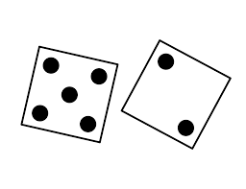 5+2=7. The student will do each exercise a total of 7 times.
- Exercises:
  - Jumping Jacks 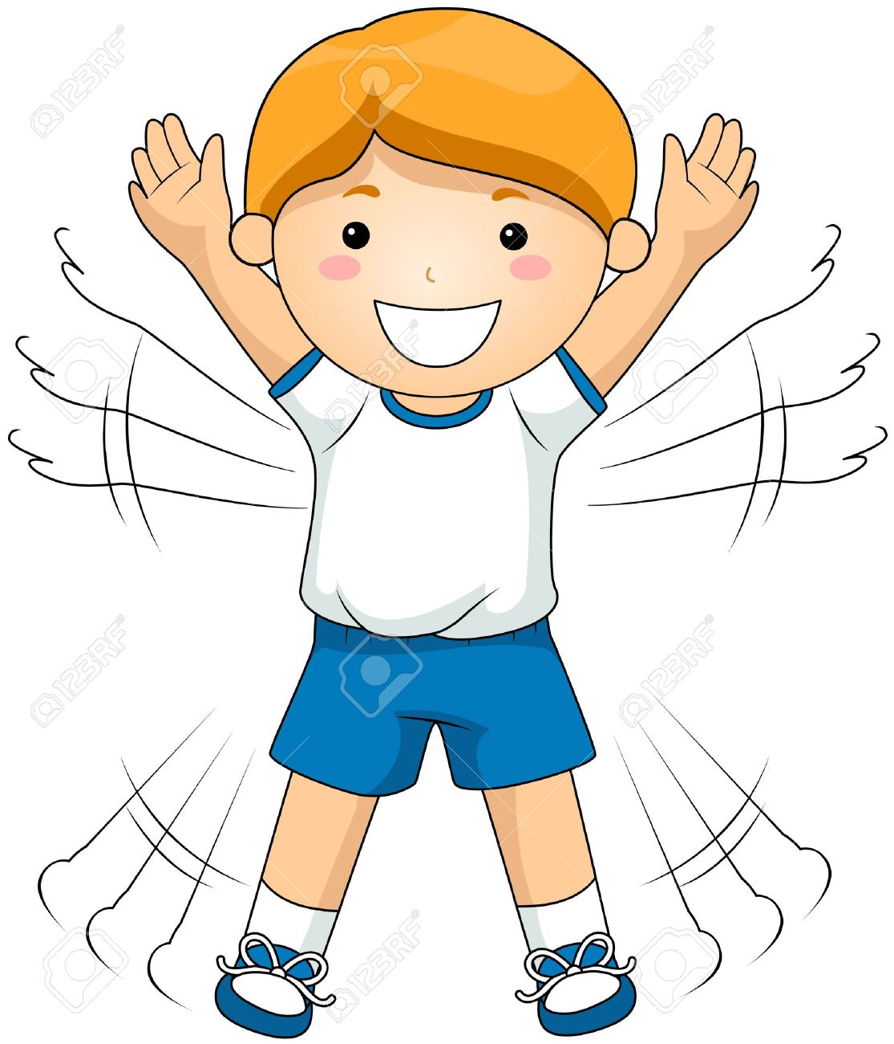
  - Push Ups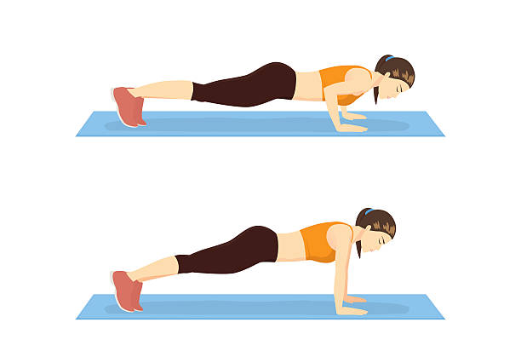
  - Sit Ups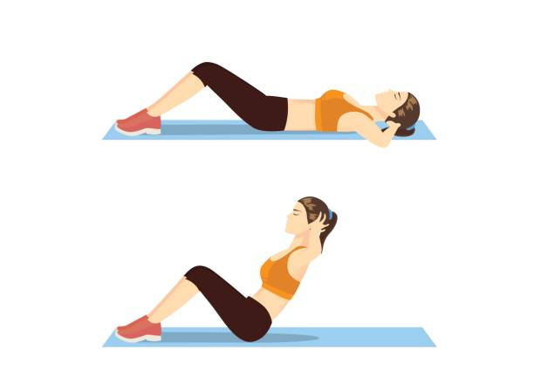
  - Toe Touches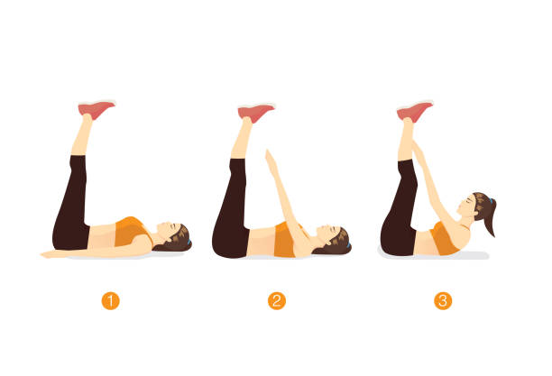
  - Arm Circles (Forward)
  - Arm Circles (Backward) 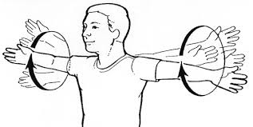
  - Squats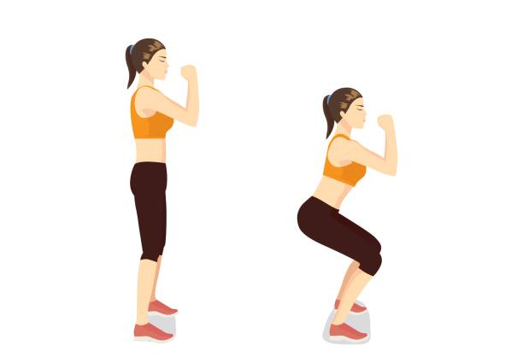
  - Legs Raises (Each Leg) 